AccessibilityOz

Web Accessibility Evaluation Tool
OzART
Keyboard

By: AccessibilityOz
Date: October 2013

Contents
Web Accessibility Evaluation Tool OzART Keyboard 1
Contents 2
Evaluating keyboard 3
Steps to take 3
Testing with OzART 5
Evaluating keyboard 5
Checklists 7
Keyboard 7
Resources 9
OzART 9
Further information 9
AccessibilityOz 9

Evaluating keyboard
Areas of importance for keyboard access are also covered specifically in the relevant category factsheets:
- Navigation
Use of main and sub navigation with and without the use of JavaScript.
- Content
Accessing links and moving around the page, avoiding reference to device-dependent handlers within page content or feature instructions.
- Coding
Controlling moving or scrolling content.
- Forms
Entering, validating and submitting information.
- Interactive site features
Using Interactive Maps and Image Maps; Slideshows; Image galleries; Virtual tours; Magazines; Calendars; Flash or JavaScript features and Java applets; Audio/Video and any other interactive object.

Steps to take
- Select a report to view from the relevant category suite of reports:
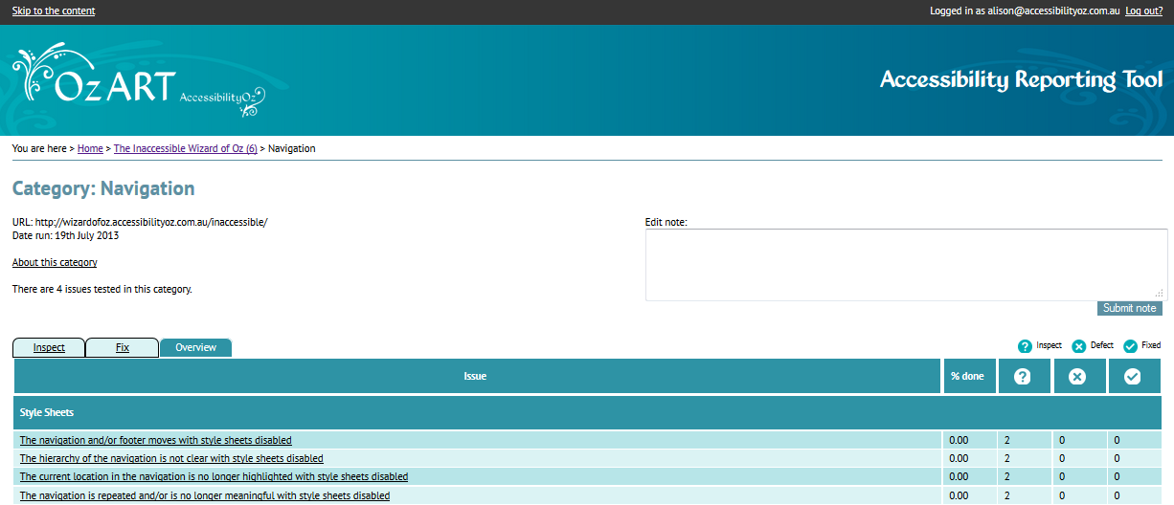
- Scroll through the report information checking that keyboard use is appropriate.
OzART is used to generate automatic lists of failures but can also be used to guide and inform the testing where specific reports are not provided leading to the creation of error specific lists of URLs for each error type which can then help with the implementation of a correction.

OzART Keyboard reports
Keyboard reports are applicable across many testing categories and the type of content displayed will change to be appropriate to the category under review. For most Keyboard issues OzART will identify the location of each appropriate piece of interactive content, however, manual testing will be required to assess the keyboard compliance.
Each Keyboard report contains the following information:
- Information about the report and a link to the relevant pages on the OzWiki;
- the WCAG 2.0 level and impact of the error under test with the report;
- the status e.g. Inspect, Defect, Fixed;
- the number of entries in the report;
- report specific information needed to determine whether the table passes or fails to comply with the requirement; and
- the referencing page i.e. the URL.
An example of an OzART keyboard issue report display is as follows:
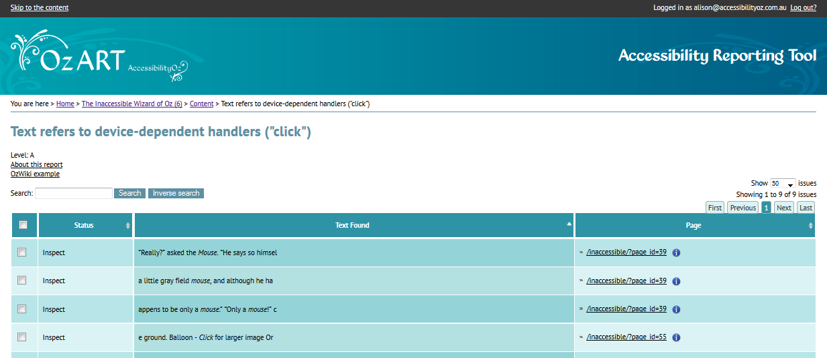

Testing with OzART

Evaluating keyboard

Manual review of the site
OzART has specific tests for some of the checklist requirements; some require manual review with and without the tool.

Automated Checking
TABINDEX has been used
Any page that is listed in this report fails KYB_A4ii
ACCESSKEY has been used
Any page that is listed in this report fails KYB_A5i

Manual checking (with the tool)
OzART will identify the location of each appropriate piece of interactive content (I.e. all Videos, all Slideshows etc.). In order for the site to be keyboard accessible, each site element or feature must be manually reviewed for keyboard use. Categories include:
- Navigation
Use of main and sub navigation with and without the use of JavaScript.
- Content
Accessing links and moving around the page, avoiding reference to device-dependent handlers within page content or feature instructions.
- Coding
Controlling moving or scrolling content.
- Forms
Entering, validating and submitting information.
- Interactive site features
Using Interactive Maps and Image Maps; Slideshows; Image galleries; Virtual tours; Magazines; Calendars; Flash or JavaScript features and Java applets; Audio/Video and any other interactive object.
Link TITLE contains additional information
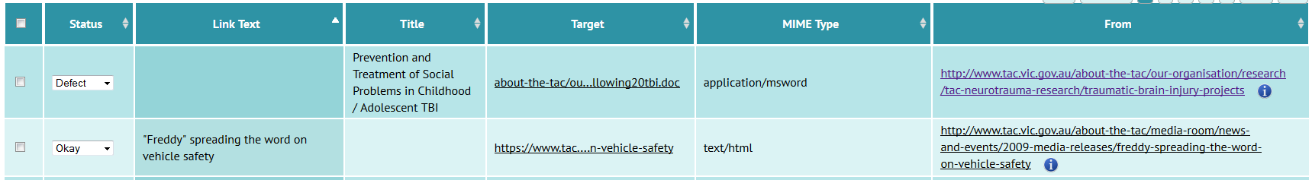
Any image that is listed in this report must pass KYB_A2ii
Image TITLE contains additional information
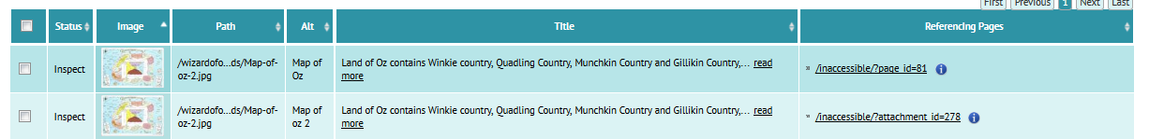
Any page that is listed in this report must pass KYB_A2iii
All page content and instructional text must be device-independent (i.e. "click" alone is not used)
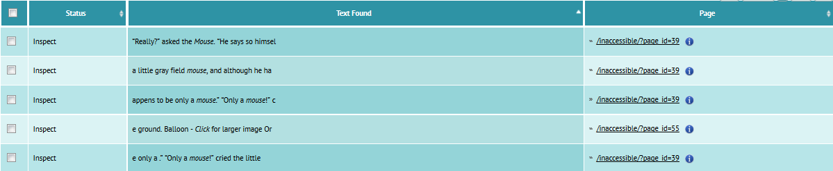
Any page that is listed in this report must pass KYB_A6

Checklists

Keyboard

Automated Checking
Ref | Requirement | Yes | No
KYB_A4ii | Is the keyboard focus order meaningful - does the TAB order preserve meaning and operability (i.e. the TABINDEX attribute has not been used as this may interfere with built-in logical tab order)?
KYB_A5i | Are standard keyboard shortcuts operable (i.e. the ACCESSKEY attribute has not been used as this may interfere with the shortcuts of the browser, operating system, or assistive technology)?

Manual checking (with the tool)
Ref | Requirement | Yes | No
KYB_A2ii | Is all content keyboard accessible (i.e. the TITLE attribute has not been used on links to present information not otherwise present on the page)?
KYB_A2iii | Is all content keyboard accessible (i.e. the TITLE attribute has not been used on images to present information not otherwise present on the page)?
KYB_A6 | Is all page content and instructional text device-independent (i.e. "click" alone is not used)?

Manual review of the site
OzART will identify the location of each piece of interactive content (i.e. all Videos, all Slideshows etc.) however, manual review is required to review keyboard use.
Ref | Requirement | Yes | No
KYB_A1 | Is the site keyboard accessible (i.e. there are no keyboard traps within the navigation, content, links, form elements, buttons or any other object control within interactive or static content of the site)?
KYB_A2i | Is all content keyboard accessible (i.e. all interactive features and static content can be fully accessed and operated with the keyboard alone)?
KYB_A3 | Does the item presentation (e.g. navigation, content, links, form elements, buttons or any other object control) change on keyboard focus?
KYB_A4i | Does all content appear on keyboard focus (i.e. the appearance of content such as tool tips is consistent with its appearance on mouse over)?
KYB_A5ii | Are standard keyboard shortcuts operable (i.e. can the navigation be operated through standard keyboard means such as using the TAB key to move across the top menu and the up and down arrow keys to move up and down the navigation dropdown)?
KYB_AA1 | Is there a highly visible keyboard focus indicator on all items (e.g. navigation, content, links, form elements, buttons or any other object control)?  Note: Although this is a AA issue, its impact on users is very high and addressing it as if it were a Level A, high impact issue is recommended.

Resources

OzART
OzART resources
http://ozart.accessibilityoz.com.au

Further information

AccessibilityOz
Web: www.accessibilityoz.com.au
Phone: 03 8677 0828
Email: enquiries@accessibilityoz.com.au
Address: Level 9, 440 Collins Street, Melbourne 3000

